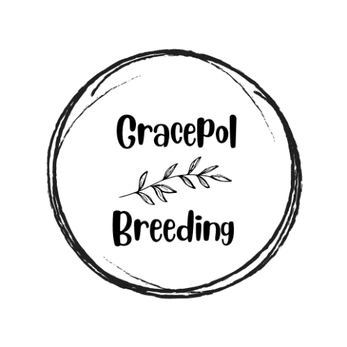

Date

Thank you for reaching out to us. We're thrilled to assist you in finding your newest Cardigan Welsh Corgi or Papillon to become a cherished member of your family. Our puppy questionnaire plays a vital role in our process, helping us match our puppies with their ideal forever homes and gaining valuable insights into your daily life. This questionnaire serves as a valuable tool for us to select the most suitable puppy from the litter, ensuring that you and your new furry family member start your journey together on the right paw. **Please be honest with your answers,** and don't hesitate to share your unique perspectives. We are not judgmental breeders, and we understand that everyone has their own way of caring for their dogs.

We invest a considerable amount of love and time into every litter, and our primary focus is to find the best-suited homes for our puppies based on their unique personalities. It's important to note that all the puppies we breed are raised within our home and are cherished members of our family from the moment they take their first breath until they depart for their new homes.

Both Cardigan Welsh Corgis and Papillons are naturally social dogs that thrive on being part of a family, which includes interactions with both humans and other canines. They require mental and physical stimulation, environmental enrichment, and a moderate level of obedience training to grow into well-balanced and happy adults. Our goal is to place our puppies in loving, secure environments with families who have a comprehensive understanding of a puppy's needs.

It's crucial to remember that puppies grow into adults, and each stage of their development comes with its own set of challenges. We encourage you to carefully consider the responsibilities that come with bringing a puppy into your life. As dedicated breeders, our utmost priority is ensuring the well-being and happiness of our puppies and their forever families.

Thank you for considering our Cardigan Welsh Corgis and Papillons. We eagerly await your completed questionnaire. Your commitment to providing a loving and responsible home is deeply appreciated, and it aligns perfectly with our goal to place our puppies in the very best hands.

# Personal Information (Used for Microchipping and Pedigree Paper transfers):

Full Name:

Address:

Contact Number:

Email Address:

Household Details:

Number of adults living in your home:

Number of children living in your home:

Ages of any children:

# Living Situation:

Type of residence:

* House with Yard
* Apartment
* Apartment block
* Townhouse
* Other

Do you rent or own your home?

* Rent
* Own

If you rent, do you have permission from your landlord to have a dog? Attach any necessary documentation.

Do you have a securely fenced yard?

* Yes
* No

# Pet Ownership History:

Have you ever owned a dog before?

* Yes
* No

If yes, what breeds and for how long?

Do you have any other pets in the house? If yes, please list their species and ages.

**Interest, Expectations and Reasons for a Puppy:**

Are you interested in a Cardigan Corgi or Papillon?

* Cardigan Corgi
* Papillon

Why are you interested in a Corgi or Papillon?

What are your expectations for your new puppy in terms of activity level, temperament, and any specific roles?

* Pet/Companion only
* Conformation showing
* Tracking
* Track & Search
* Agility/Jumping
* Retrieving
* Obedience/Rally/Assistance Work
* Breeding

Are you prepared for the responsibilities of dog ownership, including training, socialisation, exercise, grooming, and healthcare?

* Yes
* Not yet – I need more information

What is your ideal preference for your new puppy?

* Male
* Female
* Either

Do you have a colour preference for your new puppy?

# Cardigan Corgi:

* Brindle
* Blue Merle
* Red
* Black with Tan Points
* Black with Brindle Points
* Sable

# Papillon:

* Tri Colour
* Black and White
* Red, Black and White
* Sable and White

Are you open to adopting an older dog or only interested in a puppy?

* Puppy only
* Open to older dog
* Either

Are you interested in becoming a **guardian home** for one of our dogs? A guardian home program is a partnership between a breeder and a family or individual who provides a loving home for a breeding dog. In this arrangement, the breeding dog is kept as a cherished family pet in the guardian's home. The dog remains intact (not de-sexed) because it will be used for breeding purposes in the future.

**Key points about guardian homes:**

* Guardian homes offer breeding dogs the opportunity to live in a family environment, receiving love, attention, and socialisation just like any other pet.
* As the breeder, I cover the cost of the dog's breeding health care, including genetic testing, Hip and Elbow X-rays and any expenses related to breeding.
* The breeding dog will return to the breeder for specific breeding periods which are carefully planned and coordinated between the breeder and the guardian home.
* After the breeding dog's career is complete, it will be de-sexed, and ownership (pedigree) is officially transferred to the guardian home, allowing the dog to enjoy a permanent retirement in their loving home.
* Guardian homes typically enter into a legal agreement with the breeder, outlining the responsibilities and expectations of both parties. This agreement may include provisions for breeding, health care, and retirement.
* Overall, guardian homes play a crucial role in responsible breeding practices, ensuring that breeding dogs receive the love and care they deserve while contributing to the preservation and improvement of the breed.
* Yes
* No
* More information needed

How soon are you looking to get a puppy?

How did you hear about us?

# Care & Training:

How many hours a day will the puppy be alone?

Where will the puppy stay during the day?

* Indoors
* Outdoors
* Combination of both

Where will the puppy sleep at night?

Do you plan to attend obedience classes or hire a professional trainer?

* Yes
* No

# Health & Wellness:

Do you have a regular veterinarian?

* Yes
* No

If yes, please provide their name and contact details (Used for transferring electronic puppy health checks over from vet to vet):

Are you familiar with the potential health issues associated with Cardigan Corgis and Papillons?

* Yes
* No

All pet puppies, unless discussed with me, will come sterilised using the latest technology in vasectomies and tubal ligation, this means they are unable to reproduce but maintain the vital hormones needed for growth and development, this comes at no extra cost to you. Do you acknowledge this information and understand?

**Vasectomy for Males:** A vasectomy is a surgical procedure performed on male dogs. It involves the partial removal of the vas deferens, which is the duct that carries sperm from the testicles to the urethra. This procedure renders the dog sterile by preventing the release of sperm, but it doesn't affect the production of testosterone or the dog's sexual behaviour. Vasectomy is a non-reversible sterilization option.

**Tubal Ligation for Females:** Tubal ligation is a surgical procedure performed on female dogs. It involves the blocking or sealing of the fallopian tubes, which prevents eggs from traveling from the ovaries to the uterus. This procedure ensures that the dog cannot become pregnant but maintains her normal hormonal cycle. Tubal ligation is a non-reversible sterilization option.

* Yes
* No
* I would like to discuss with you in more detail

Have you considered pet insurance?

* Yes
* No
* I already have it/had it for a previous pet

Are you aware of the council requirements in your area regarding pet ownership?

* Yes
* No

Lastly this space is provided for you to tell me anything else about yourself that will help me assess if your puppy would thrive in your home (e.g. your interests and hobbies, future plans i.e. starting a family, moving to a new house, etc)

Declaration: I hereby declare that the information provided in this questionnaire is true to the best of my knowledge. I understand that any false information may result in my application being rejected.

Signature: ________________________

Date: _______________

Thank you for your interest in our Cardigan Corgis & Papillons! We will review your questionnaire and be in touch soon.

Jess & Nick